<https://nordicapis.com/5-examples-of-apis-we-use-in-our-everyday-lives/>





API : Application Programming Interface

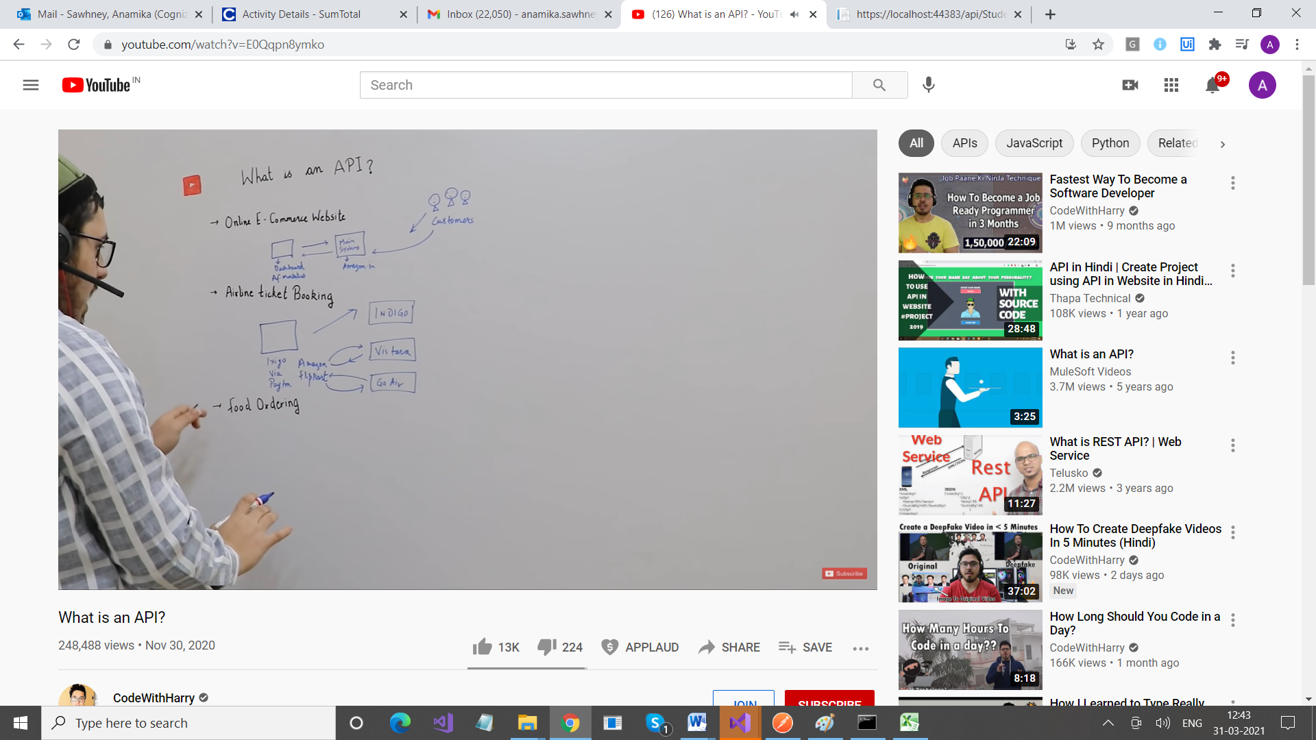

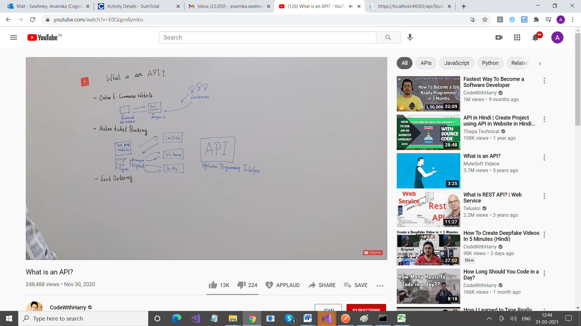





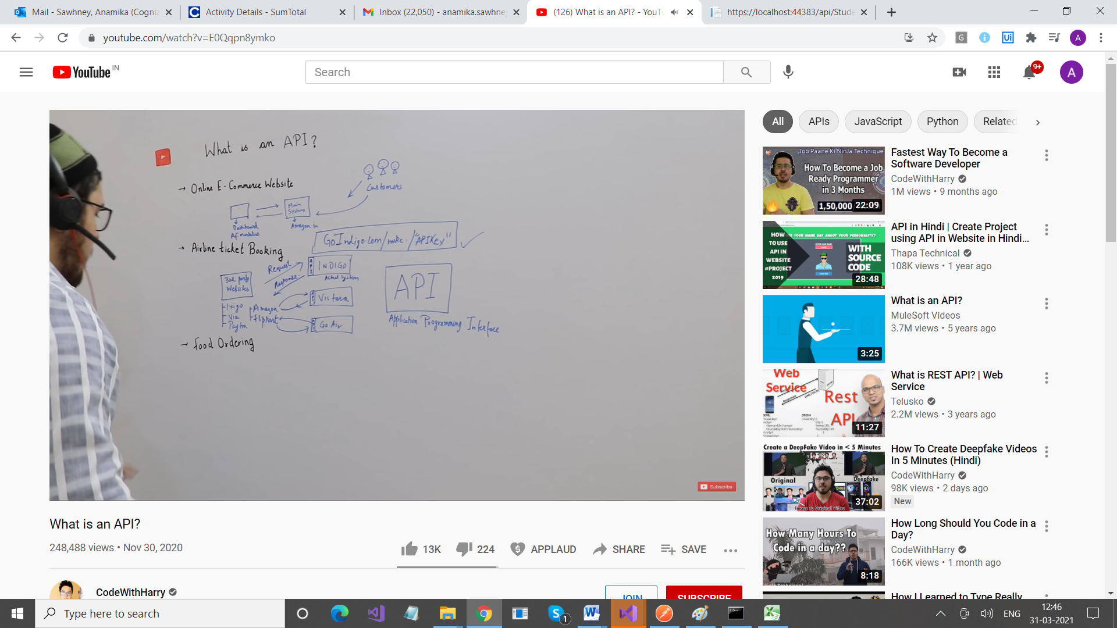

API makes it possible for different systems to interact with each other

API helps all these systems (INDIGO, ect) to expose their data.

So Indigo and Amazon will interact via API

Example of Customer & Waiter & Chef

Here Waiter is API